Step 1 - Create Project
mkdir -p ~/k8s-playwright-basic-setup/{tests,k8s}
cd ~/k8s-playwright-basic-setup

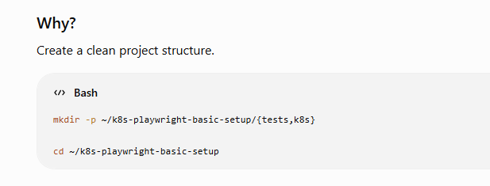

Step 2 - Initialize Node Project

apt install npm
npm init -y
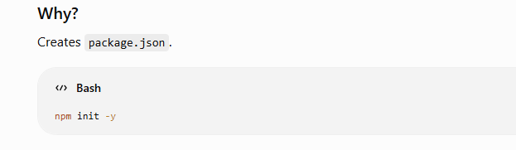

Step 3 - Install Playwright
npm install -D @playwright/test
npx playwright install chromium

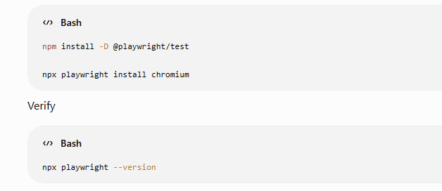

Step 4 - Create Playwright Configuration
cat << EOF > playwright.config.ts
import { defineConfig } from '@playwright/test';
export default defineConfig({
timeout: 30000,
use: {
headless: true
}
});
EOF

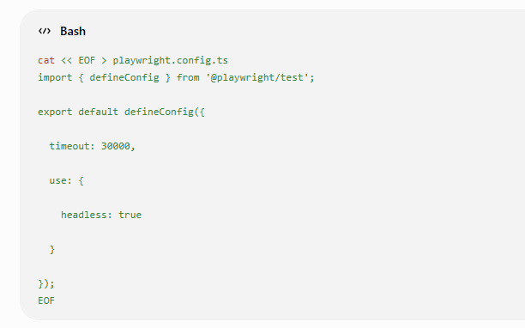

Step 5 - Create Test
cat << EOF > tests/sample.spec.ts
import { test, expect } from '@playwright/test';

const BASE_URL =
process.env.BASE_URL ||
'https://playwright.dev';

test('Verify homepage', async ({ page }) => {

await page.goto(BASE_URL);

await expect(page).toHaveTitle(/Playwright/);

});
EOF

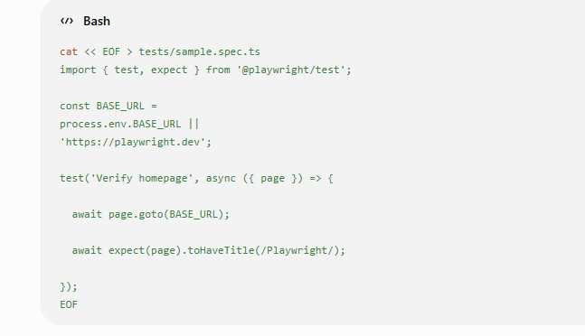

Step 6 - Run Tests Locally

npx playwright test

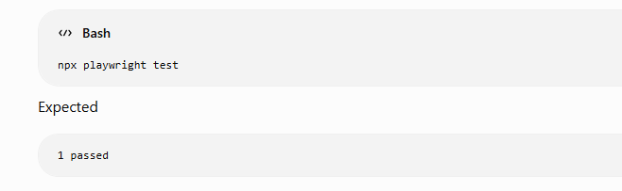

Name space
mkdir k8s/namespaces

for dev
cat > k8s/namespaces/dev.yaml << 'EOF'
apiVersion: v1
kind: Namespace
metadata:
name: dev
EOF

For prod

cat > k8s/namespaces/prod.yaml << 'EOF'
apiVersion: v1
kind: Namespace
metadata:
name: prod
labels:
environment: production
tier: backend
annotations:
description: "Production environment namespace"
EOF

For staging

cat > k8s/namespaces/staging.yaml << 'EOF'
apiVersion: v1
kind: Namespace
metadata:
name: staging
labels:
environment: staging
tier: backend
annotations:
description: "Staging environment namespace"
EOF

Command
kubectl apply -f k8s/namespaces/dev.yaml
kubectl apply -f k8s/namespaces/prod.yaml
kubectl apply -f k8s/namespaces/staging.yaml
kubectl get namespaces

Create ConfigMaps

mkdir -p k8s/configmaps

For dev

cat <<EOF > k8s/configmaps/dev-config.yaml
apiVersion: v1
kind: ConfigMap

metadata:
name: nginx-config
namespace: dev

data:
APP_NAME: "Playwright Demo"
BASE_URL: "http://nginx-service"
ENVIRONMENT: "Development"
TIMEOUT: "30000"
EOF

For staging

cat <<EOF > k8s/configmaps/staging-config.yaml
apiVersion: v1
kind: ConfigMap

metadata:
name: nginx-config
namespace: staging

data:
APP_NAME: "Playwright Demo"
BASE_URL: "http://nginx-service"
ENVIRONMENT: "Production"
TIMEOUT: "60000"
EOF

prod
cat <<EOF > k8s/configmaps/prod-config.yaml
apiVersion: v1
kind: ConfigMap

metadata:
name: nginx-config
namespace: prod

data:
APP_NAME: "Playwright Demo"
BASE_URL: "http://nginx-service"
ENVIRONMENT: "Production"
TIMEOUT: "60000"
EOF

Apply the ConfigMaps

kubectl apply -f k8s/configmaps/staging-config.yaml
kubectl apply -f k8s/configmaps/dev-config.yaml
kubectl apply -f k8s/configmaps/prod-config.yaml

verify
kubectl get configmaps -n dev
kubectl get configmaps -n staging
kubectl get configmaps -n prod
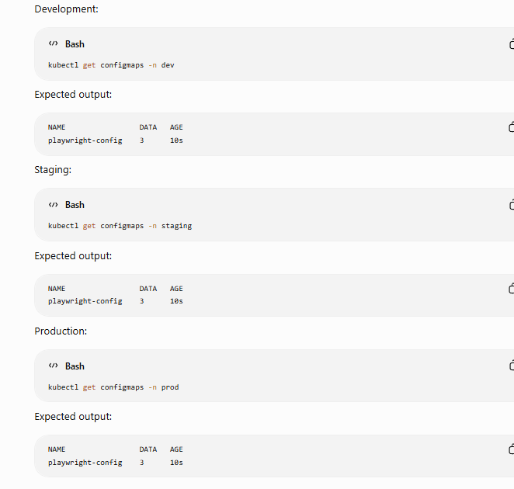

Step 3: Create Secrets
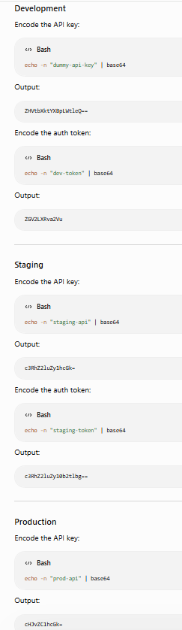

mkdir -p k8s/secrets

dev-secret

cat <<EOF > k8s/secrets/dev-secret.yaml
apiVersion: v1
kind: Secret

metadata:
name: nginx-secret
namespace: dev

type: Opaque

stringData:
API_KEY: devapikey
AUTH_TOKEN: devtoken
EOF

staging-secret.yaml
cat <<EOF > k8s/secrets/staging-secret.yaml
apiVersion: v1
kind: Secret

metadata:
name: nginx-secret
namespace: staging

type: Opaque

stringData:
API_KEY: stagingapikey
AUTH_TOKEN: stagingtoken
EOF

prod-secret.yaml
cat <<EOF > k8s/secrets/prod-secret.yaml

apiVersion: v1
kind: Secret

metadata:
name: nginx-secret
namespace: prod

type: Opaque

stringData:
API_KEY: prodapikey
AUTH_TOKEN: prodtoken
EOF

Command
kubectl apply -f k8s/secrets/dev-secret.yaml
kubectl apply -f k8s/secrets/staging-secret.yaml
kubectl apply -f k8s/secrets/prod-secret.yaml
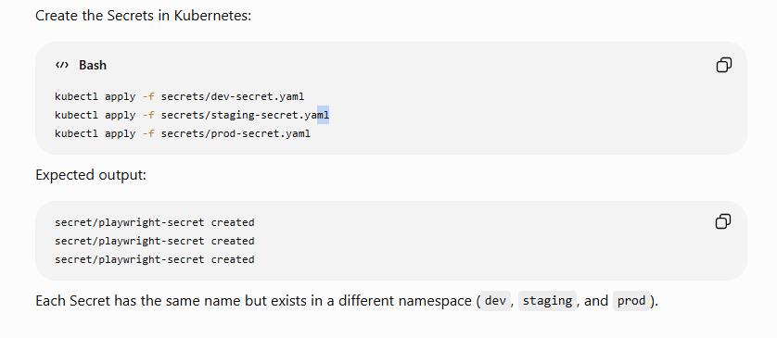

Verify the Secrets

kubectl get secrets -n dev
kubectl get secrets -n staging
kubectl get secrets -n prod

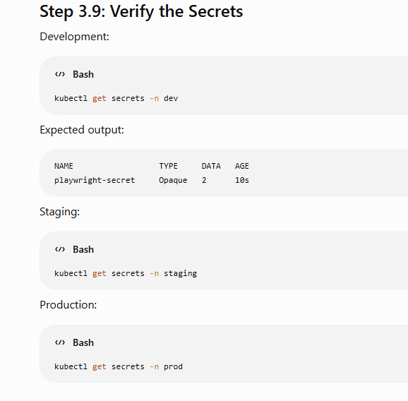

Step 4: Create Deployments

mkdir k8s/deployments

dev
cat <<EOF > k8s/deployments/dev-deployment.yaml
apiVersion: apps/v1
kind: Deployment

metadata:
name: nginx-deployment
namespace: dev

spec:
replicas: 1

selector:
matchLabels:
app: playwright-demo
env: dev

template:
metadata:
labels:
app: playwright-demo
env: dev

spec:
containers:
- name: nginx
image: nginx:latest
imagePullPolicy: Always

ports:
- containerPort: 80

envFrom:
- configMapRef:
name: nginx-config

- secretRef:
name: nginx-secret
EOF

staging

cat <<EOF > k8s/deployments/staging-deployment.yaml
apiVersion: apps/v1
kind: Deployment

metadata:
name: nginx-deployment
namespace: staging

spec:
replicas: 1

selector:
matchLabels:
app: playwright-demo
env: staging

template:
metadata:
labels:
app: playwright-demo
env: staging

spec:
containers:
- name: nginx
image: nginx:latest
imagePullPolicy: Always

ports:
- containerPort: 80

envFrom:
- configMapRef:
name: nginx-config

- secretRef:
name: nginx-secret
EOF

prod

cat <<EOF > k8s/deployments/prod-deployment.yaml
apiVersion: apps/v1
kind: Deployment

metadata:
name: nginx-deployment
namespace: prod

spec:
replicas: 1

selector:
matchLabels:
app: playwright-demo
env: prod

template:
metadata:
labels:
app: playwright-demo
env: prod

spec:
containers:
- name: nginx
image: nginx:latest
imagePullPolicy: Always

ports:
- containerPort: 80

envFrom:
- configMapRef:
name: nginx-config

- secretRef:
name: nginx-secret
EOF

Command
kubectl apply -f k8s/deployments/dev-deployment.yaml
kubectl apply -f k8s/deployments/staging-deployment.yaml
kubectl apply -f k8s/deployments/prod-deployment.yaml
kubectl get deployments -A
kubectl get pods -A

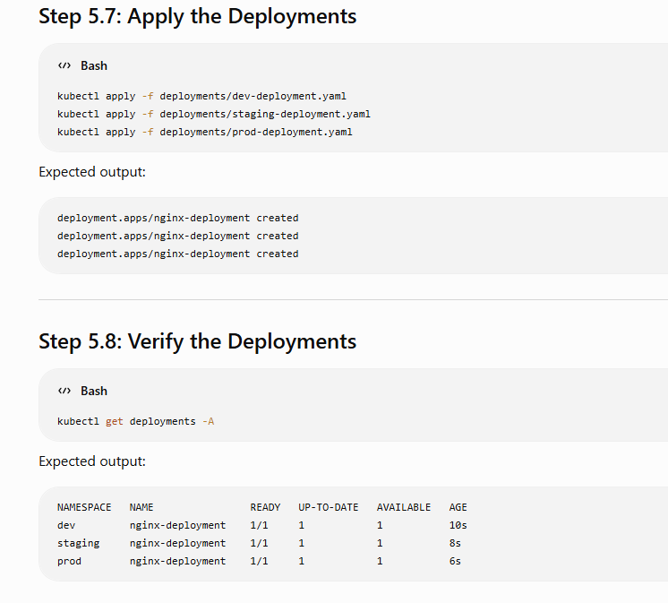
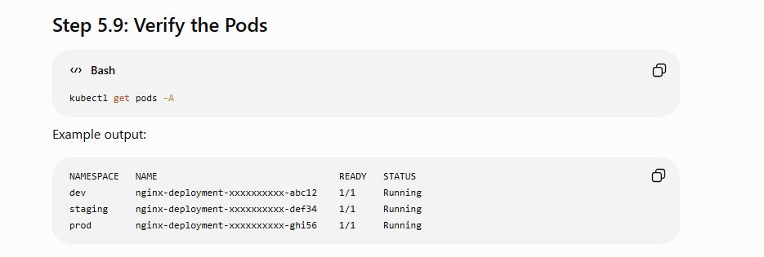

Create Resource Quotas

mkdir k8s/resourcequotas

dev
cat <<EOF > k8s/resourcequotas/dev-quota.yaml
apiVersion: v1
kind: ResourceQuota

metadata:
name: dev-quota
namespace: dev

spec:
hard:
pods: "5"
requests.cpu: "1"
requests.memory: 1Gi
limits.cpu: "2"
limits.memory: 2Gi
EOF

staging
cat <<EOF > k8s/resourcequotas/staging-quota.yaml
apiVersion: v1
kind: ResourceQuota

metadata:
name: staging-quota
namespace: staging

spec:
hard:
pods: "10"
requests.cpu: "2"
requests.memory: 2Gi
limits.cpu: "4"
limits.memory: 4Gi
EOF

prod

cat <<EOF > k8s/resourcequotas/prod-quota.yaml
apiVersion: v1
kind: ResourceQuota

metadata:
name: prod-quota
namespace: prod

spec:
hard:
pods: "20"
requests.cpu: "4"
requests.memory: 4Gi
limits.cpu: "8"
limits.memory: 8Gi
EOF

Command
ls resourcequotas

kubectl apply -f k8s/resourcequotas/dev-quota.yaml
kubectl apply -f k8s/resourcequotas/staging-quota.yaml
kubectl apply -f k8s/resourcequotas/prod-quota.yaml

kubectl get resourcequota -A

kubectl get resourcequota -n dev
kubectl get resourcequota -n staging
kubectl get resourcequota -n prod

kubectl describe resourcequota dev-quota -n dev

Scripts
mkdir k8s/scripts

dev
cat <<EOF > k8s/scripts/deploy-dev.sh
#!/bin/bash

echo "===================================="
echo "Deploying Development Environment..."
echo "===================================="

kubectl apply -f namespaces/dev.yaml
kubectl apply -f configmaps/dev-config.yaml
kubectl apply -f secrets/dev-secret.yaml
kubectl apply -f resourcequotas/dev-quota.yaml
kubectl apply -f deployments/dev-deployment.yaml

echo ""
echo "Resources in dev namespace:"
kubectl get all -n dev

echo ""
echo "Deployment completed successfully!"
EOF

staging

cat <<EOF > k8s/scripts/deploy-staging.sh
#!/bin/bash

echo "===================================="
echo "Deploying Staging Environment..."
echo "===================================="

kubectl apply -f namespaces/staging.yaml
kubectl apply -f configmaps/staging-config.yaml
kubectl apply -f secrets/staging-secret.yaml
kubectl apply -f resourcequotas/staging-quota.yaml
kubectl apply -f deployments/staging-deployment.yaml

echo ""
echo "Resources in staging namespace:"
kubectl get all -n staging

echo ""
echo "Deployment completed successfully!"
EOF

prod
cat <<EOF > k8s/scripts/deploy-prod.sh
#!/bin/bash

echo "===================================="
echo "Deploying Production Environment..."
echo "===================================="

kubectl apply -f namespaces/prod.yaml
kubectl apply -f configmaps/prod-config.yaml
kubectl apply -f secrets/prod-secret.yaml
kubectl apply -f resourcequotas/prod-quota.yaml
kubectl apply -f deployments/prod-deployment.yaml

echo ""
echo "Resources in prod namespace:"
kubectl get all -n prod

echo ""
echo "Deployment completed successfully!"
EOF

Cleanup
cat <<EOF > k8s/scripts/cleanup.sh
#!/bin/bash

echo "===================================="
echo "Cleaning up Kubernetes Resources..."
echo "===================================="

kubectl delete namespace dev --ignore-not-found
kubectl delete namespace staging --ignore-not-found
kubectl delete namespace prod --ignore-not-found

echo ""
echo "Cleanup completed."
EOF

Command
chmod +x k8s/scripts/*.sh
ls -l k8s/scripts
cd ~/k8s-playwright-basic-setup/k8s

. scripts/deploy-dev.sh

